**Kirby-Vass Insulation, Inc.**

#### Firestop of Virginia, Inc.

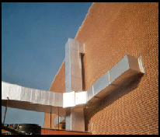

# Trusted since 1986

=

Safety and Quality before everything else

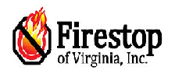

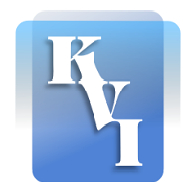

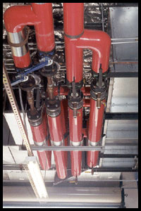

**Samples of FSOVA’s work**

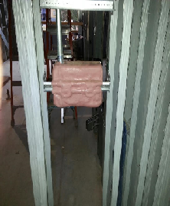

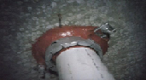

Kirby-Vass Insulation, Inc.

263 Industrial Dr.

Roanoke, VA 24019

Phone: 540.992.3960

1-800-277-6163

Fax: 540.992.4796

E-mail: [gcundiff@kirby-vassinsulation.com](mailto:gcundiff@kirby-vassinsulation.com)

tkirby@kirby-vassinsulation.com

Website: <http://www.kirby-vassinsulation.com/homepage/>

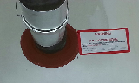

Phone: 540.992.3960

1-800-277-6163

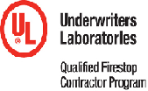

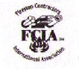

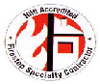

**Equal Opportunity Employer**

#### About Us Equal Opportunity Employer

[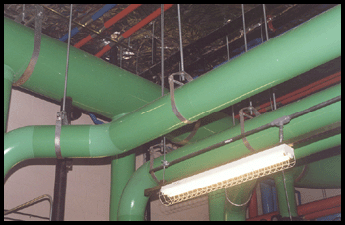](http://www.kirby-vassinsulation.com/kvisworkscrapbook/view_alone.nhtml?profile=kvisworkscrapbook&UID=10004)

Kirby-Vass Insulation, Inc.

We provide quality insulation products from the top manufacturers. We carry fiberglass, foam rubber, calcium silicate, mineral wool, urethane, and styrofoam. We also offer a variety of finishes, from all-service jackets to the following: PVC, aluminum, stainless steel, fiberglass cloth, canvas, and mastic. Serve in southwest, central, and northern Virginia, as well as parts of West Virginia and North Carolina. We are constantly growing and serving a larger area. This is due to our commitment to efficient and timely service combined with our high quality and competitive pricing.

# Firestop of Virginia, Inc.

In 2001 Kirby-Vass Insulation, Inc. started Firestop of Virginia. FSOVA is now one of the leading fire stop companies on the East Coast. FSOVA is a full service fire stop contractor. We provide services for Through Penetrations, Top & Bottom of Wall applications, Acoustics, Construction Joint and Curtain walls. FSOVA is a Hilti Platinum Fire Stop Installer. In 2009 FSOVA completed stringent testing and developed an intense management program required to become UL Qualified. At the time of qualification FSOVA was only the 15th contractor in the nation to achieve this, and are currently the only UL Qualified contractor in Virginia. FSOVA covers areas in VA,, WV, TN, and NC.

# Kirby-Vass Insulation, Inc.

Kirby-Vass Insulation, Inc., specializes in the insulation of pipes, ductwork, and equipment for industrial and commercial needs. Insulation affects you and your company in many ways. The most important benefit that you receive with proper insulation is safety. Proper insulation protects you, your employees, and the pipes, equipment, and ductwork in your building. Whether you are in an office or an industrial building, effective insulation can save energy, reduce noise, stop condensation, and provide protection.

Firestop of Virginia, Inc.

Kirby-Vass Insulation, Inc.

